**CP Club 365 Days Challenge**

**Programming language – C++**

**Problem Statement**

<https://www.codechef.com/problems/GDTURN>

Git :- <https://github.com/Vedantbharad2603/CP_club_365_Days>

**Your Code**:

// 0x135Day of 0x365Days challenge

// VEDANT BHARAD

// 02-03-2023

#include <iostream>

using namespace std;

int main() {

    // your code goes here

    int t;

    cin >> t;

    while (t--) {

        int x, y;

        cin >> x >>y;

        if((x+y)>6)

        {

            cout<<"YES"<<endl;

        }

        else{

            cout<<"NO"<<endl;

        }

    }

    return 0;

}

**Output (Screen Shot)**:

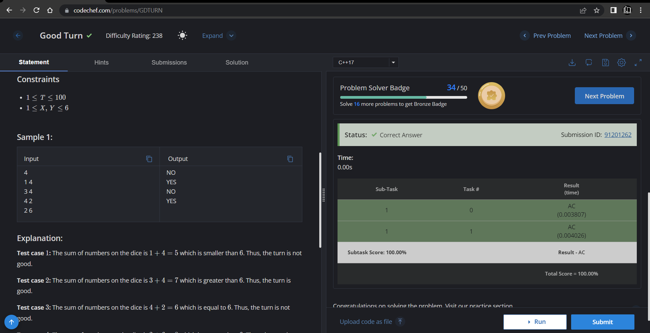

**Understanding about problem:**

* In this task if sum of x and y higher then 6 then return YES else return NO.

Note: If you can't understand the problem, feel free to contact us and we'll help you. Please don't copy and paste from anywhere.

ALL THE BEST

Team CP Club